ASSET TOKENIZATION: Decentralized Platform for Real-World Asset Tokenization Using Blockchain

Omkar Bharath Pukale
Student
Department of CSE
AMC Engineering College, Bengaluru, Karnataka, India
omkarbharathpukale@gmail.com
Premkumar M K
Assistant Professor
Department of CSE
AMC Engineering College, Bengaluru, Karnataka, India premkumarmk@gmail.com
Dr. V Mareeswari Professor & HOD Department of CSE
AMC Engineering College, Bengaluru, Karnataka, India mareesh.prasanna@gmail.com

Sahil Kumar Mishra
Student
Department of CSE
AMC Engineering College,
Bengaluru, Karnataka, India
sahilmishra7069@gmail.com
Sandesh G C
Student
Department of CSE
AMC Engineering College, Bengaluru, Karnataka, India
sandysandesh148@gmail.com
Sanjitha A
Student
Department of CSE
AMC Engineering College, Bengaluru, Karnataka, India
sanjitha0987@gmail.com

Abstract— This work presents a blockchain-based platform for representing real-world assets as digital tokens and supporting fractional ownership. The proposed system allows users to access smaller portions of assets such as real estate and commodities, making investment more flexible and reducing the limitations of conventional asset markets. Ownership and token transactions are handled through Solidity smart contracts, which provide automated validation and transparent record keeping. The platform combines React.js and Node.js with MongoDB for the application layer and connects to the Ethereum Sepolia test network via Hardhat for executing blockchain operations. It demonstrates a practical approach to secure asset management, simplified investment, and transparent ownership transfer.
Keywords - Asset Tokenization, Fractional Ownership, Blockchain Technology, Smart Contracts, Ethereum.

INTRODUCTION
Asset tokenization provides a way to represent ownership of physical assets through digital units recorded on a blockchain. It can divide assets such as property, commodities, and artwork into smaller portions, allowing people to invest without purchasing an entire asset. This approach can make participation easier for smaller investors while also supporting better movement of ownership in markets that are normally difficult to access. In the proposed system, smart contracts manage the creation, transfer, and verification of asset tokens, reducing manual intervention and keeping transaction records consistent. The application uses React.js, Node.js, and MongoDB to support the user interface, application functions, and asset information. It also connects with an Ethereum test network for blockchain transactions. Together, these components provide a practical platform for listing assets, purchasing tokens, checking transactions, and demonstrating how blockchain can support simpler and more transparent asset ownership. Users can also view asset details and ownership information through the same platform. This makes asset investment and ownership easier to manage.

II. LITERATURE SURVEY
Recent studies examine asset tokenization from legal, financial, regulatory, and technical perspectives. Nishith Desai Associates [1] discusses legal and compliance issues in real-estate tokenization, including fractional ownership and regulatory requirements. Agur et al. [2] study how tokenization can reduce market inefficiencies while improving liquidity, settlement, and financial access. The World Economic Forum [3] highlights fractional ownership, programmability, transparency, and interoperability as important benefits of tokenized assets, while also identifying adoption and compliance challenges. Soni et al. [4] examine the role of distributed ledger technology in representing and transferring real-world assets, with emphasis on efficiency and accessibility. IFSCA [5] discusses the regulatory framework for real-world asset tokenization, covering issuance, trading, custody, and settlement requirements. Benedetti and Rodríguez-Garnica [6] examine tokenized assets and securities and report potential benefits such as lower trading friction, transparency, wider market participation. Although the existing studies explain the legal, financial, and regulatory sides of tokenization in detail, they give less attention to building a working prototype that demonstrates the process from token creation to ownership transfer. This project focuses on that practical side. It implements fractional ownership, token transactions, and ownership management through Solidity smart contracts and a supporting web application. The aim is to show, through an actual prototype, how blockchain can be used to record ownership and manage transactions in a more transparent way.
III. SYSTEM ARCHITECTURE
The proposed platform is organized into five layers: presentation, application and logic, persistence, blockchain and smart contracts, and wallet with development and testing. Each layer has a role, while the arrangement allows the components to work together without putting every operation in one place. This structure makes the system easier to develop, test, and maintain.
The presentation layer uses React.js to provide the interface for users. It allows them to browse tokenized assets, check balances, view holdings, and follow transaction details. MetaMask is connected to the interface so user can review and approve blockchain operations through their wallet. The layout is kept simple so functions can be used without detailed blockchain knowledge. The application and logic layer is built with Node.js and Express.js. It manages authentication, receives requests from the frontend, applies application rules, and coordinates communication with MongoDB and smart contracts. This layer processes each operation before it reaches the blockchain component.
The persistence layer uses MongoDB to store user profiles, asset descriptions, images, and other application data. Keeping these details off-chain reduces blockchain storage and allows information to be retrieved efficiently. Ownership records remain associated with the blockchain layer. The blockchain and smart contract layer uses Solidity contracts to create tokens, transfer ownership, and validate transactions. For this project, the contracts are deployed and tested on the Ethereum Sepolia test network using the Hardhat development environment. This setup allows the system to be evaluated under realistic network conditions while verifying transaction finality. The development and testing layer utilizes MetaMask, Hardhat, and Remix IDE. Hardhat serves as the primary environment for compiling, testing, and deploying smart contracts to the public test network, bridging the application logic with the blockchain. Together, these layers connect the interface, application, database, wallet, and blockchain into one prototype. The architecture keeps application data separate from ownership operations while providing a practical setup for demonstrating tokenized asset management.
IV. METHODS & IMPLEMENTATION
The project methodology describes the systematic approach followed to design, develop, and evaluate the proposed asset tokenization platform. It outlines the major phases involved in the project, starting from requirement analysis and system design to implementation, testing, and validation. Following a structured methodology helped ensure that the system was developed in an organized manner while meeting the intended objectives.
Requirement Analysis
The first step of the project was to identify the limitations of the existing asset ownership system. Traditional investment methods often require high capital, provide limited liquidity, and do not easily support fractional ownership. Based on these challenges, the system requirements were defined to develop a platform that enables secure asset tokenization, transparent ownership management, and easy trading of digital asset tokens.
System Design
After gathering the requirements, the overall system architecture was designed by dividing the application into five main components: the frontend, backend, database, blockchain network and wallet. Each component performs a specific task while working together as a complete system. This modular design makes the application easier to develop, test, maintain, and enhance in the future.
Asset Fractionalization
The first step in the tokenization process is to divide the underlying real-world asset into smaller digital units. For this purpose, the project uses the ERC-20 token standard through the Property Token.sol smart contract. Instead of representing the complete property as a single ownership unit, the property is represented through multiple fungible tokens that can be distributed among different users. This allows an investor to hold only a portion of the asset rather than having to purchase the complete property. The fractionalization process therefore reduces the size of the individual ownership units and forms the basic foundation for the trading mechanism used in the platform. Users can own a part instead of purchasing the complete property. This division is the basis for token trading functions used in the platform.
Dynamic Pricing and Liquidity Mechanism
To provide continuous liquidity and automated asset pricing, the platform implements a hybrid Automated Market Maker (AMM) model. Instead of executing complex matching algorithms directly on the blockchain, which incurs significant gas costs, the pricing logic is processed by the application backend. The system applies a constant product formula to calculate token prices dynamically based on the available token supply and the initial asset valuation.
When a user initiates a trade, the backend computes the exact transaction cost. It then interfaces directly with the smart contract to mint or burn the corresponding ERC-20 property tokens. This off-chain calculation approach significantly reduces transaction fees for the end user while ensuring that final token ownership records remain securely verifiable on the Ethereum network.
Smart Contract Development
The smart contracts were developed using Solidity to manage asset tokenization and ownership transfer. They are responsible for creating tokens, verifying transactions, and maintaining ownership records on the blockchain. Validation checks were included to ensure that only valid transactions are processed, helping improve the security and reliability of the system.
Frontend and Backend Development
The user interface was developed using React.js to provide a simple and interactive experience. Users can connect their MetaMask wallet, browse available assets, purchase tokens, and view their transaction history and portfolio. The backend was implemented using Node.js and Express.js, which handle user authentication, process requests, and communicate with both the database and blockchain. MongoDB is used to store user information and asset details that do not need to be recorded on the blockchain, improving the overall efficiency of the application.
Testing and Validation
After completing the development phase, the system was tested to ensure that all modules functioned correctly. Functional testing verified features such as users registration, login, asset listing, token purchase, and ownership updates. Smart contract testing confirmed that token creation, ownership transfer, and validation rules worked as expected. Additional testing was carried out to evaluate system performance, security, and usability. Performance testing measured response time and transaction processing, while security testing ensured that unauthorized access and invalid transactions were prevented. Integration testing confirmed smooth communication between the frontend, backend, database, MetaMask, and blockchain. Finally, usability testing ensured that the interface was easy to understand and allowed users to complete transactions without difficulty.

V. TECHNICAL STACK
The platform is designed using a layered architecture to make the system organized, secure, and easy to manage. Rather than handling every operation in one place, the work is divided across five different layers, with each layer responsible for a specific function. This structure allows the platform to support blockchain-based asset ownership while keeping the implementation practical within the project's scope. From displaying an asset on the website to finally transferring ownership as a digital token, every stage is handled by the appropriate layer.
Presentation Layer
The presentation layer is developed with React.js and provides the main interface for users. Through the dashboard, users can view available assets, check token holdings, see wallet balances, and track previous transactions. MetaMask is connected to the application so that users can approve blockchain transactions from their own wallets. The interface is designed to keep the main operations simple, allowing users to interact with tokenized assets without directly handling blockchain code.
Application/Logic Layer
Node.js and Express.js form the application and logic layer. This layer receives requests from the frontend, manages authentication, performs application-level checks, and provides the required APIs. It also coordinates communication between the frontend, MongoDB, and the blockchain. When a users performs an operation such as purchasing tokens or transferring ownership, the backend helps process the request and connects it with the appropriate smart contract functions.
Persistence Layer
MongoDB is used as the persistence layer for information that does not need to be stored directly on the blockchain. Users profiles, asset descriptions, images, and related application data are maintained in the database. Keeping this information off-chain reduces unnecessary blockchain storage and allows the application to retrieve regular data more efficiently. Ownership-related records, however, continue to be maintained through the blockchain.
Blockchain and Smart Contract Layer
The blockchain and smart contract layer is implemented using Solidity and the Ethereum test network. Smart contracts handle important operations such as token creation, ownership transfer, and transaction validation. Since these records are maintained on the blockchain, changes can be verified through the network rather than relying only on the application database. The contracts are developed and checked using Remix IDE and Hardhat before being used with the test network.
Wallet and Development/Testing Layer
MetaMask provides the wallet connection required for users to sign and authorize blockchain transactions. During development, Hardhat is utilized to simulate a local node environment and manage deployments to the Sepolia public test network. This configuration allows developers to verify contract behavior, transaction accuracy, and wallet connections before final production deployment. Hardhat and Remix IDE are also used during contract development and verification. Different test cases are performed to check transaction accuracy, wallet connectivity, contract behavior, and communication between the application components. Problems found during testing are corrected before deployment to the Ethereum test network, helping improve the stability of the prototype.
VI. RESULTS AND DISCUSSION
The prototype was evaluated through functional, smart-contract, integration, security, and usability tests. The checks focused on the main operations of the platform, including asset listing, wallet connection, token creation, token purchase, ownership transfer, and transaction validation. The tests were initially verified using local testing frameworks and subsequently executed on the Ethereum Sepolia test network. This ensured that the smart contracts functioned correctly under standard network conditions, accounting for realistic block confirmation times and gas limits. The observed results show that the main modules could communicate correctly and that invalid operations were rejected by the validation rules in the contracts. MetaMask provided the required wallet interaction, while MongoDB handled application data separately from blockchain records. Some additional users guidance was needed for wallet-related steps, especially for users unfamiliar with blockchain applications. Overall, the prototype successfully demonstrated the intended asset-tokenization workflow at a local development level, while public-network deployment, larger-scale load testing, and production-level regulatory checks remain outside the scope of the current implementation. The tests showed that the main prototype functions operated as expected under evaluated conditions.
Token Transaction and Ownership Testing
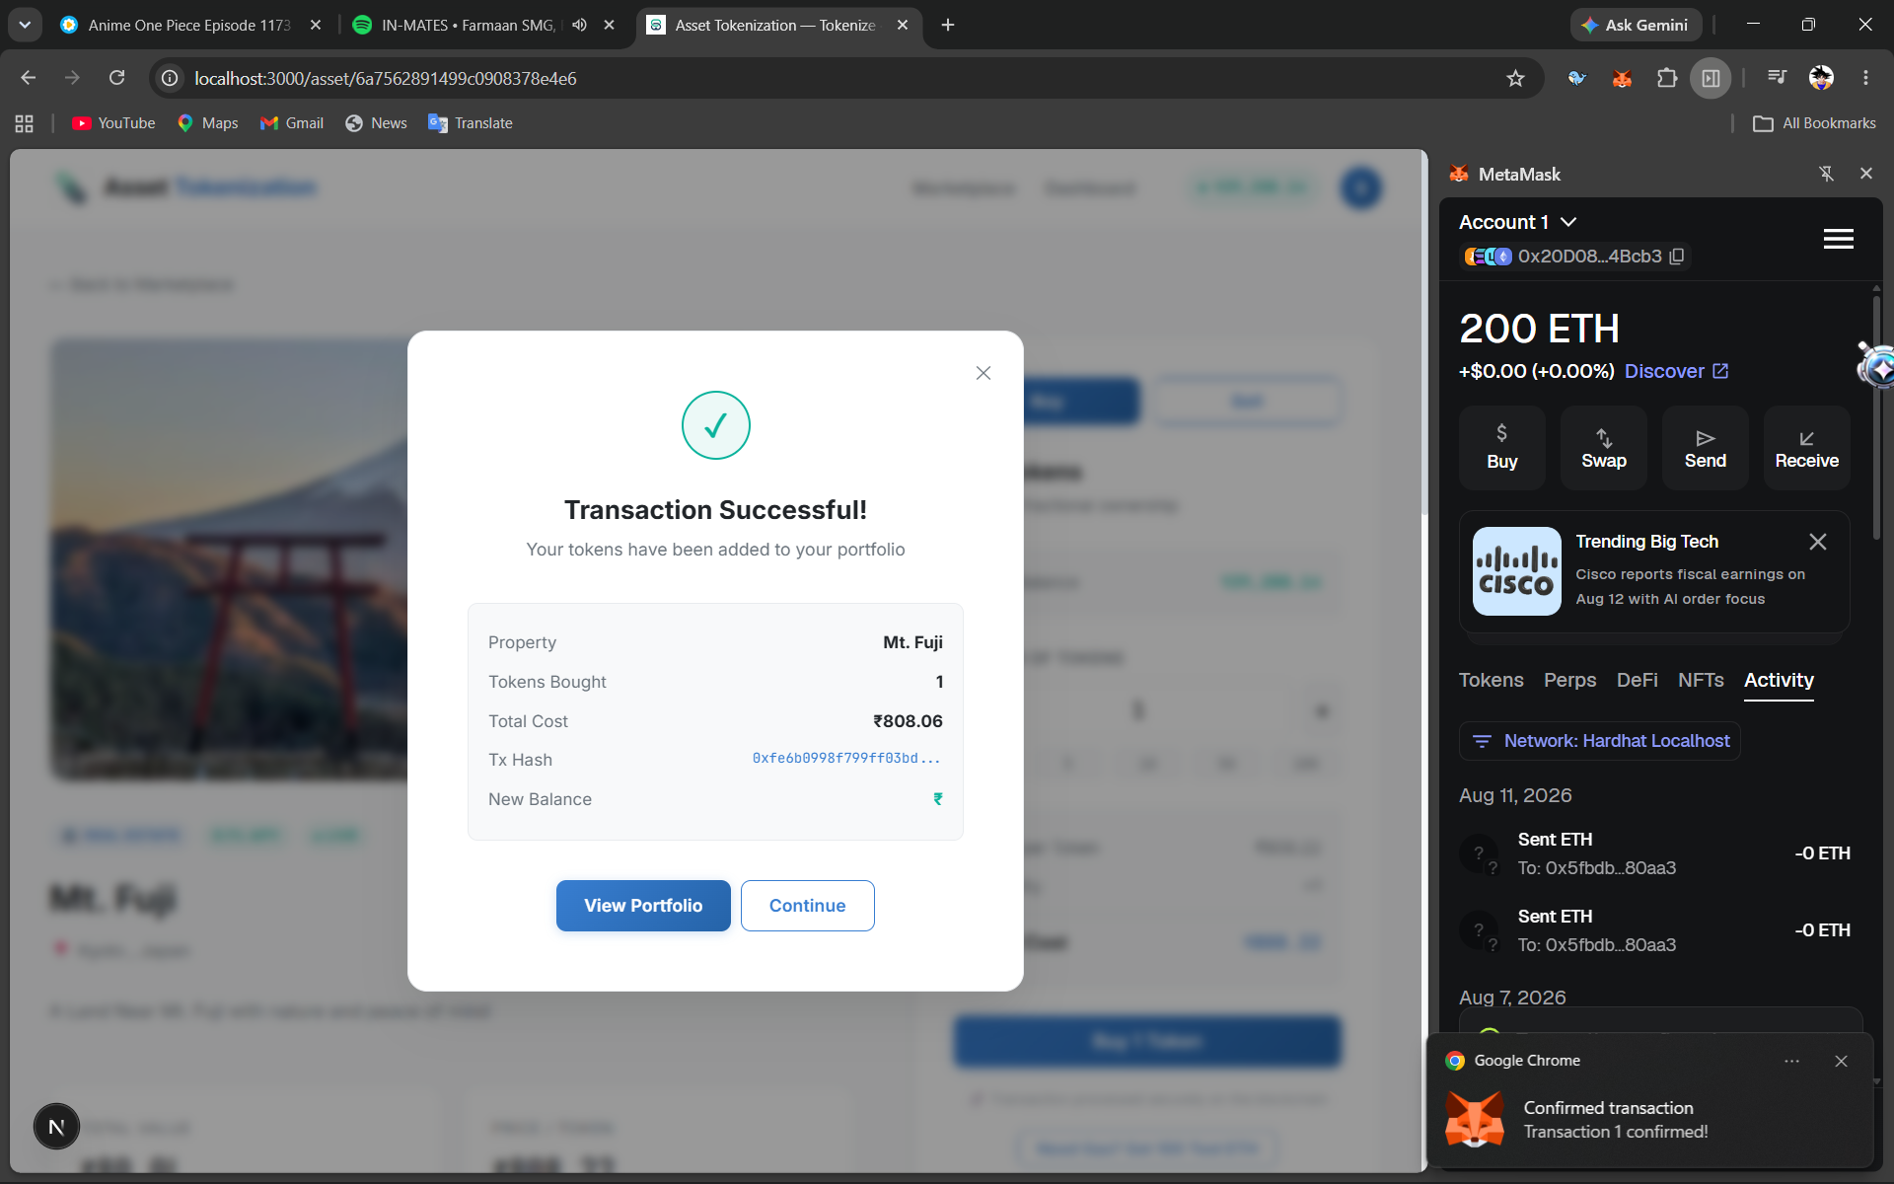
Figure 1. Token Transaction and Ownership Testing
The token tests were used to check whether asset tokens could be created, transferred, and associated with the correct wallet addresses. Validation conditions in the Solidity contracts rejected invalid inputs and prevented unintended state changes. We needed to ensure that whenever a user minted or purchased a fractional share, the token balances updated correctly without dropping any transactions. After successful transactions, the ownership information observed through the contract state matched the expected transfer. These tests indicate that the smart-contract logic was able to maintain consistent ownership updates during the prototype evaluation. This confirmed that our core token logic holds up under basic trading conditions and accurately maps wallet addresses to their respective real-world asset shares. Our test cases included both valid transfers and intentional failure states designed to trigger smart contract rollbacks. Across all successful tests, the final contract state consistently aligned with the expected ownership distribution, verifying that the underlying transfer logic operates securely.
Transaction Processing
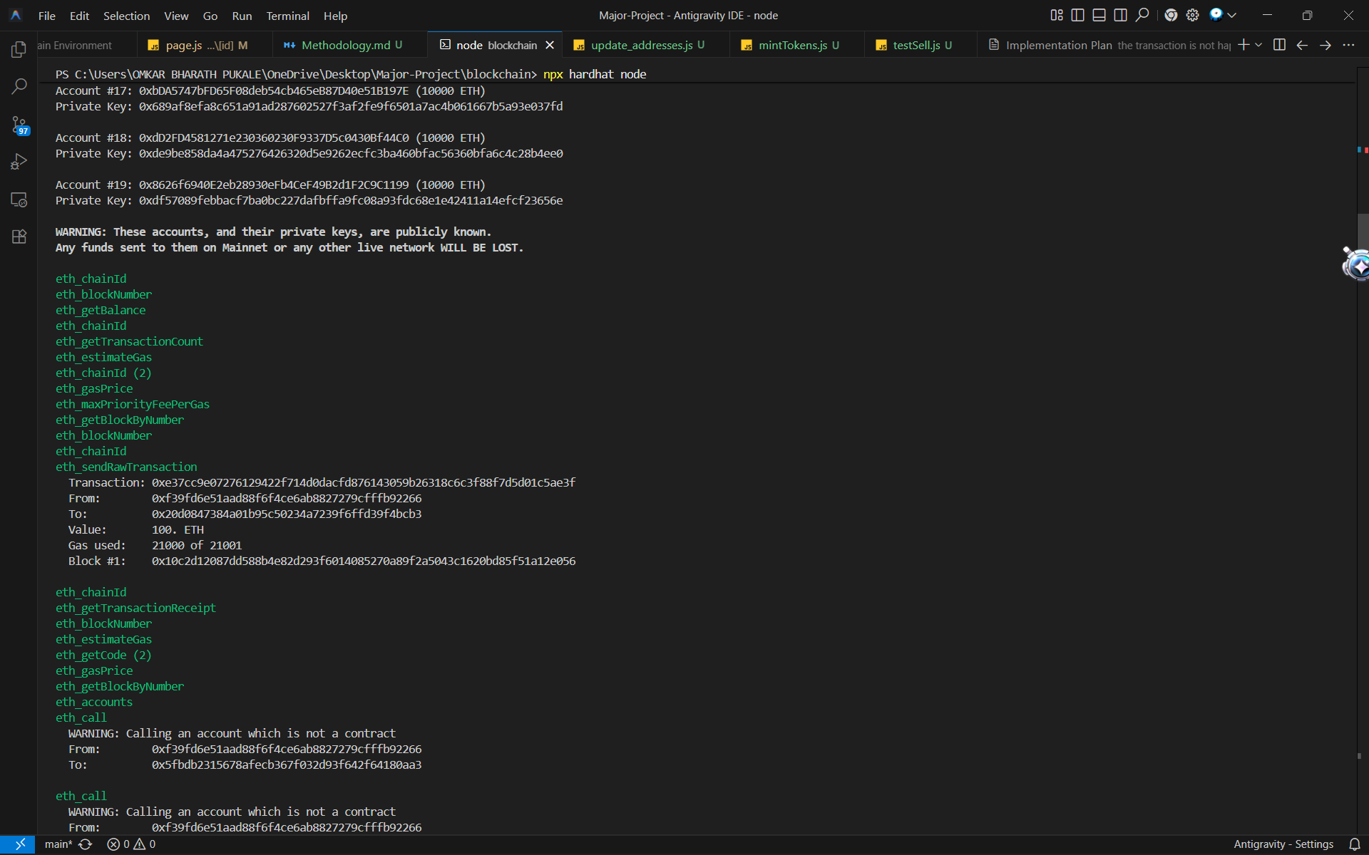
Figure 2. Transaction Processing Observation
During the evaluation of transaction processing, the platform was tested against the Ethereum Sepolia test network. This public testnet deployment provided a realistic environment for measuring transaction latency, gas estimations, and block confirmation times. The tests demonstrated that while blockchain operations inherently require more processing time compared to standard database updates—due to the necessity of network consensus and state confirmation—the system reliably completed the automated minting and burning operations. Observing the prototype in this live testnet environment confirmed its capability to handle real-world transaction flows securely.
Ownership Record Consistency
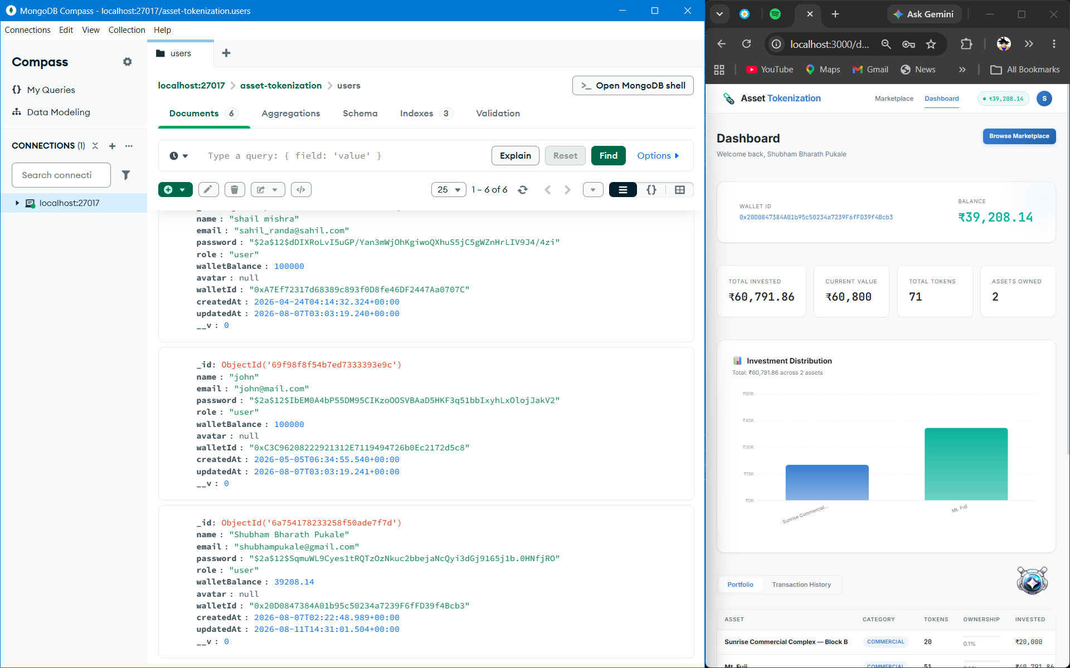
Figure 3. Ownership Record Consistency
Ownership records were checked after fractional token transfers between different test accounts. The checks showed that the token balances changed according to the completed transactions and that the contract state reflected the resulting ownership. No duplicate ownership update was observed during the tested cases. This supports the use of the smart contract as the authoritative record for token ownership in the prototype.
Asset Search and Data Retrieval
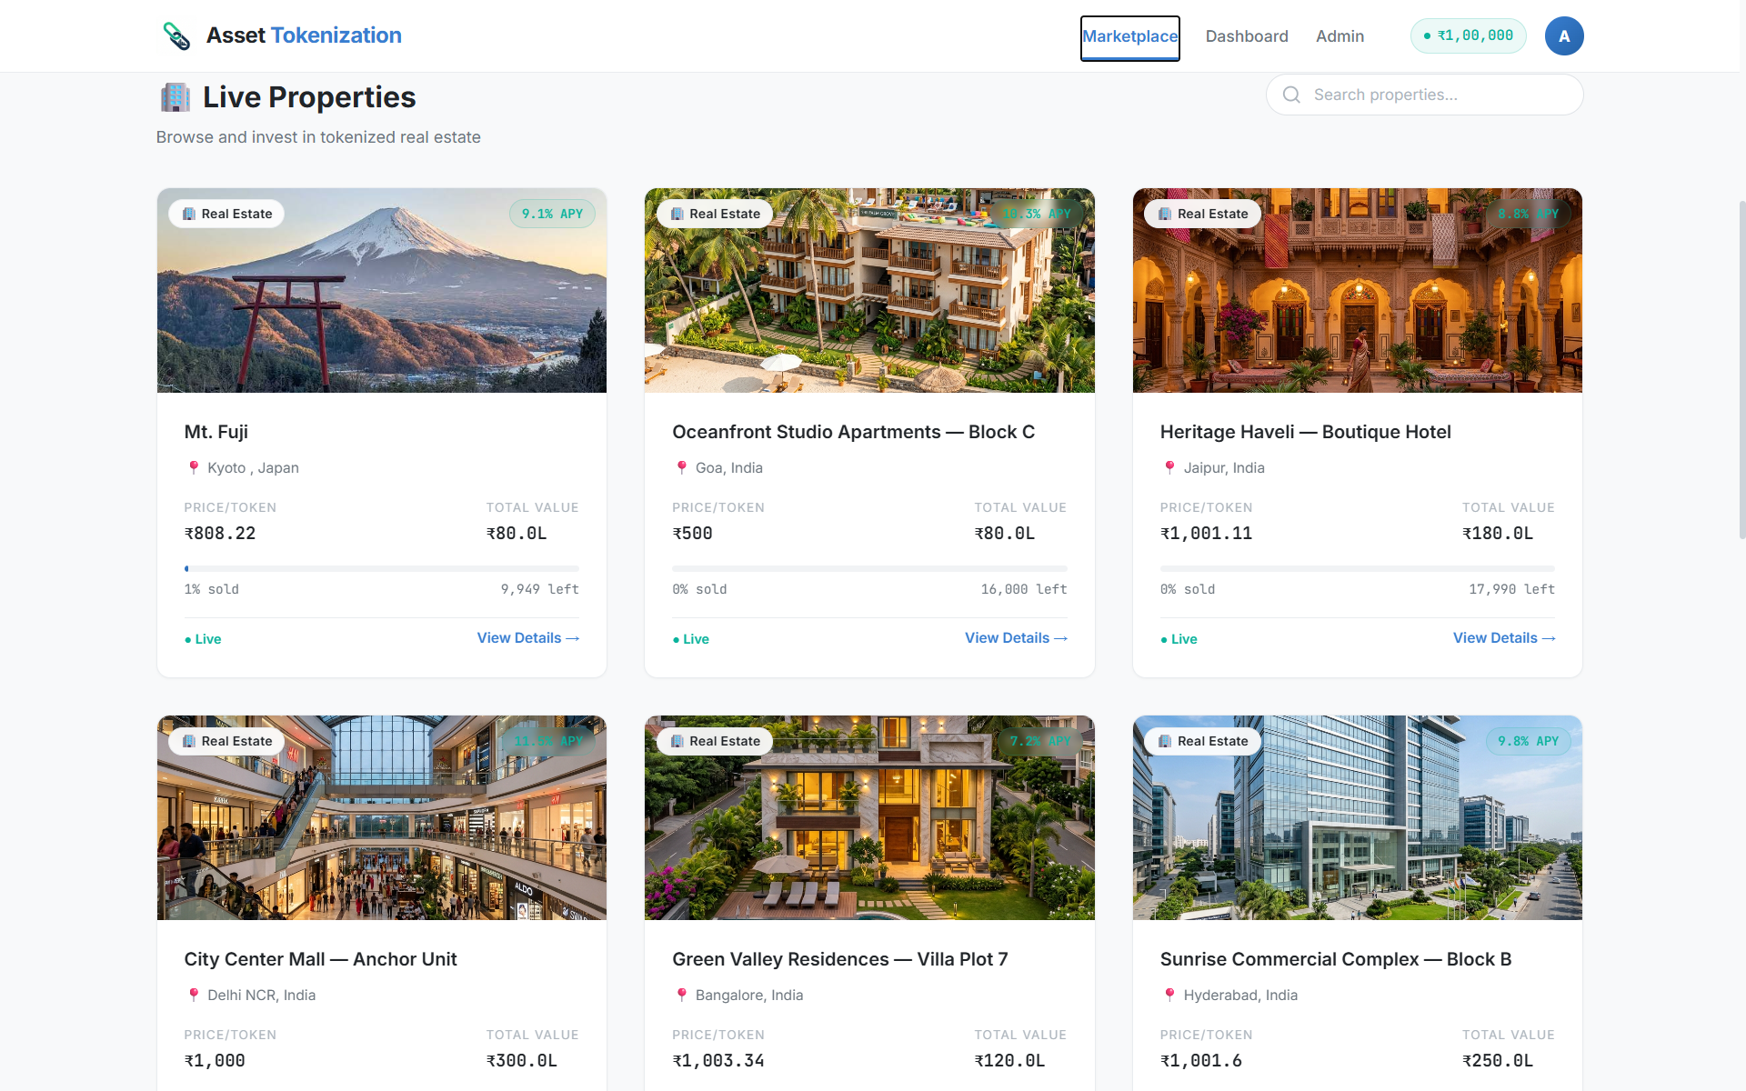
Figure 4. Asset Search and Data Retrieval
Asset information was retrieved from MongoDB through the application layer, while ownership-related information was obtained from the blockchain component when required. This separation allowed regular asset details to be handled through the database without placing every field on-chain. The tests confirmed that the application could retrieve the stored asset information and connect it with the corresponding token-related operations.
System Integration and Scalability
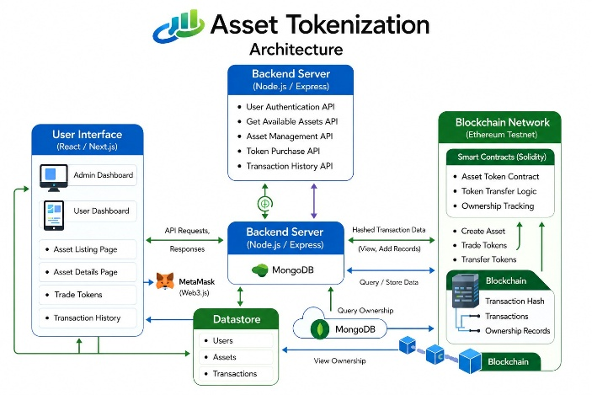
Figure 5. System Integration and Scalability
Integration testing focused on communication among React.js, Node.js and Express.js, MongoDB, MetaMask, and the local blockchain. The main users flow could be completed by moving from asset selection to wallet authorization and then to the corresponding blockchain operation. Testing also helped identify issues in communication and transaction handling, which were corrected during development. A large-scale concurrent-users benchmark was not performed, so the prototype is not presented as having been validated for production-level scalability.
VII. CONCLUSION
The main aim of this project was to develop a blockchain-based platform that demonstrates how real-world assets can be represented digitally and divided into smaller ownership units. The prototype connects React.js, Node.js, MongoDB, MetaMask, and the Ethereum Sepolia test network to manage asset information, token ownership, and transactions. Using smart contracts for ownership operations provides a clear record of token transfers within the prototype and reduces dependence on manual updates.
The platform was developed using separate frontend, backend, database, and blockchain components. Dividing the system in this way helped during development and testing, as each part could be handled independently while still working together as a complete application. The testing carried out on the prototype showed that important functions such as user authentication, asset tokenization, token purchase, ownership transfer, and transaction validation were working correctly. However, some practical issues were also observed, particularly the time required for blockchain transactions and the steps involved in connecting a user wallet. These are areas that would need further attention in a more advanced version of the system.
The results indicate that the proposed approach can demonstrate fractional asset ownership and blockchain-based transaction handling in a controlled environment. The current implementation is limited to a prototype and has not been presented as a production investment platform. Future work can include deployment on a suitable public blockchain, support for additional asset types, stronger scalability testing, improved wallet usability, and more detailed regulatory and security evaluation. These additions would be needed before considering a real-world deployment.
Another important outcome of the project is that it shows how blockchain can be applied to areas beyond cryptocurrency. By combining familiar web technologies with smart contracts and decentralized ownership records, the developed platform provides a simple approach to representing and managing fractional ownership digitally. There are still technical, regulatory, and usability aspects that need to be addressed before such a system can be used commercially. However, the prototype provides a working demonstration that asset tokenization is technically possible and could become a useful approach for managing and accessing ownership of valuable real-world assets in the future.
VIII. REFERENCES
[1] Nishith Desai Associates, “Real Estate Tokenisation — Legal, Tax and Regulatory Considerations,” Mar. 2025.
[2] I. Agur, G. Villegas-Bauer, T. Mancini-Griffoli, M. S. Martinez Peria, and B. Tan, “Tokenization and Financial Market Inefficiencies,” IMF Fintech Note 2025/001, International Monetary Fund, Jan. 2025, doi: 10.5089/9798400298905.063.
[3] World Economic Forum, “Asset Tokenization in Financial Markets: The Next Generation of Value Exchange,” Insight Report, May 21, 2025.
[4] U. Soni, O. Fines, and J. Sun, “An Investment Perspective on Tokenization — Part I: A Primer on the Use of Distributed Ledger Technology to Tokenize Real-World and Financial Assets,” CFA Institute, Jan. 22, 2025.
[5] International Financial Services Centres Authority, “Regulatory Approach towards Tokenization of Real-World Assets,” Consultation Paper, Feb. 26, 2025.
[6] H. E. Benedetti and G. Rodriguez-Garnica, “Tokenized Assets and Securities,” SSRN, Dec. 2021, doi: 10.2139/ssrn.4069119.

